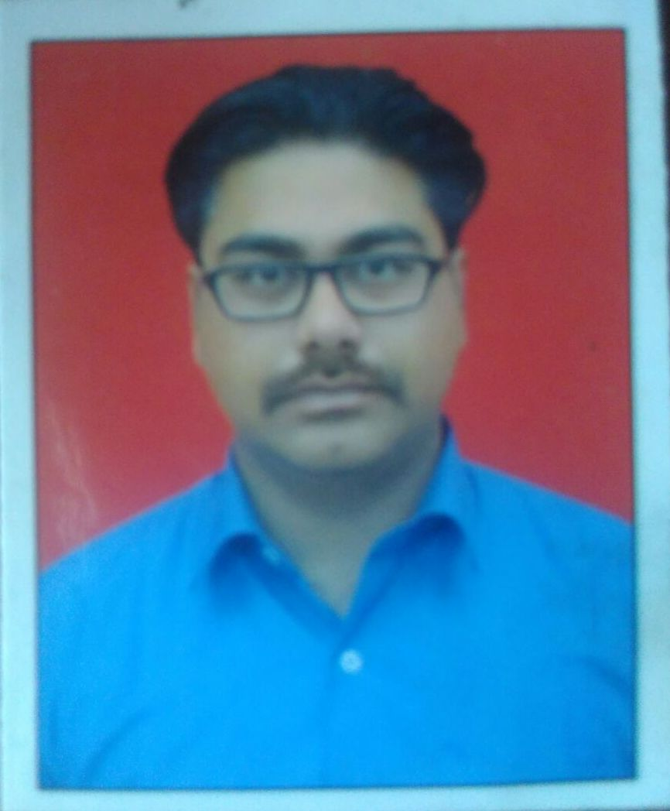
CURICULUM VITAE

GAURAV WALIA
# 9896692433

Gauravwalia1985@yahoo.com

CHANNEL SALES & MARKETING PROFESSIONAL

CAREER OBJECTIVE :-
I would like to work in an organization that allows me to utilize my unique background, skills and talent so as to realize my full creative potential in an environment that encourages continuous learning teamwork and quality. A self-starter with excellent and analytical and communication skills and never say die attitude and a team player with an aptitude to rise to the occasion

PRESENTLY EMPLOYED:-
Company Profile:-  March 2017 to Till Date |  | SOMANY CERAMICS LTD ( AMBALA HARYANA )
Designation –  Job Profile:- |  | Senior Territory Manager  - Manage overall channel sales & marketing operations for a network dealers across the designated region, dealing in a range of Paints products  - Collect orders from retailers/dealers while coordinating with logistics department for timely fulfillment of same  - Maintain relation with Distributors  - Monthly Achieve Sales target  - Looking after Payments  - Work within Company norms to achieve Targets.
Company Profile:-  May 2016 – March 2017 |  | SHALIMAR PAINTS ltd. ( Ambala Haryana )
Designation:-  Job Profile:- |  | SR.SALE EXECUTIVE  - Manage overall channel sales & marketing operations for a network of dealers across the designated region, dealing in a range of Tile products  - Architect & Builder working  - Collect orders from retailers/dealers while coordinating with logistics department for timely fulfillment of same  - Maintain relation with Distributors  - Monthly Achieve Sales target  - Looking after Payments  - Work within Company norms to achieve Targets.
Company Profile:-  July.2015 - April 2016 |  | VARMORA GRANITO PVT LTD ( AMBALA HARYANA )
Designation –  Job Profile:- |  | Sales Officer  - Manage overall channel sales & marketing operations for a network dealers across the designated region, dealing in a range of Paints products  - Collect orders from retailers/dealers while coordinating with logistics department for timely fulfillment of same  - Maintain relation with Distributors  - Monthly Achieve Sales target  - Looking after Payments  - Work within Company norms to achieve Targets.
Company Profile:-  July.2015 - April 2016 |  | VARMORA GRANITO PVT LTD ( AMBALA HARYANA )
Designation:-  Job Profile:- |  | SR.SALE EXECUTIVE  - Manage overall channel sales & marketing operations for a network of dealers across the designated region, dealing in a range of Tile products  - Architect & Builder working  - Collect orders from retailers/dealers while coordinating with logistics department for timely fulfillment of same  - Maintain relation with Distributors  - Monthly Achieve Sales target  - Looking after Payments  - Work within Company norms to achieve Targets.
Company Profile:-  July.2011– July.2015 |  | ORIENT BELL LIMITED ( PATIALA PUNJAB )
Designation:-  Job Profile:- |  | SALE EXECUTIVE  - Maintain relation with Distributors & Dealers  - Monthly Achieve Sales target  - Looking after Payments  - Work within Company norms to achieve Targets.
EDUCATION:
Degree / Certificate | University / Institution |  |  | % of Marks | Year
MBA | National Institute of Business Management (NIBM ) |  |  | 65.00 | 2010
BA | Kurukshetra University, Kurukshetra |  |  | 51.00 | 2005
12th | H.B.S.E. Bhiwani |  |  | 52.00 | 2002
10th | H.B.S.E. Bhiwani |  |  | 59.00 | 2000
PERSONAL SKILLS:
- Good communication skills
- Optimistic and creative approach
- Team building, coordinating and leading skills
- Adaptable to all types of working conditions

PERSONAL DETAILS:
Name |  |  | Gaurav Walia
Fathers Name |  |  | Sh. Amar Jeet Walia
Date of Birth |  |  | 18th June, 1985
Nationality |  |  | Indian
Marital Status |  |  | Married
Languages Known |  |  | English, Hindi, Punjabi
Permanent Address |  |  | Vpo Adhoya Tel.Barara Ambala

Hereby I confirm that the information above mentioned is true to the best of my knowledge.

(GAURAV WALIA)

